Finding Best model based on accuracy and hyper tuning the parameters

PROBLEM STATEMENT: HR - domain: Salary Prediction

SIMPLE LINEAR REGRESSION:
Model accuracy = 0.9740993407213511 (r2_score)

PROBLEM STATEMENT: Profit prediction for startups based on the investment rate in different departments

MULTIPLE LINEAR REGRESSION
Model accuracy = 0.9358680970046243 (r2_score)

SUPPORT VECTOR MACHINE – REGRESSION

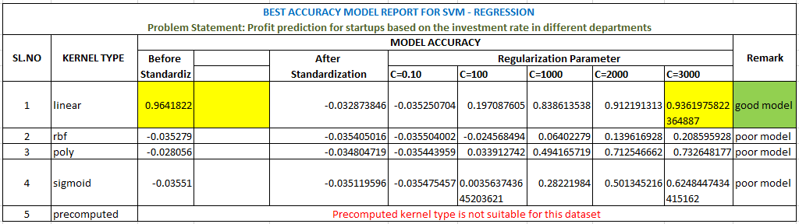

Best model:
Linear kernel type with accuracy: 0.964182234713478

DECISION TREE – REGRESSION

MODEL ACCURACY BEFORE HYPER TUNING PARAMETERS = 0.9103968927441213 (r2_score)

BEST ACCURACY MODEL REPORT FOR DECISION TREE - REGRESSION
Problem Statement: Profit prediction for startups based on the investment rate in different departments
SL.NO | criterion | splitter | max_features | model accuracy
1 | squared_error | best | None | 0.922979943
2 | friedman_mse | best | None | 0.894627024
3 | absolute_error | best | None | 0.865925655
4 | poisson | best | None | 0.919949059
5 | squared_error | best | sqrt | 0.775658783
6 | friedman_mse | best | sqrt | 0.771178363
7 | absolute_error | best | sqrt | 0.595995028
8 | poisson | best | sqrt | 0.749254538
9 | squared_error | best | log2 | 0.642397099
10 | friedman_mse | best | log2 | 0.844147648
11 | absolute_error | best | log2 | 0.795328222
12 | poisson | best | log2 | 0.558185539
13 | squared_error | random | None | 0.836494878
14 | friedman_mse | random | None | 0.864614099
15 | absolute_error | random | None | 0.889412835
16 | poisson | random | None | 0.892430605
17 | squared_error | random | sqrt | 0.819796564
18 | friedman_mse | random | sqrt | 0.51976595
19 | absolute_error | random | sqrt | 0.816672645
20 | poisson | random | sqrt | 0.74125826
21 | squared_error | random | log2 | 0.418840624
22 | friedman_mse | random | log2 | 0.74045325
23 | absolute_error | random | log2 | 0.700267496
24 | poisson | random | log2 | 0.687695992

Best model:
squared_error criterion with accuracy: 0.922979943062626

